Deimos Zipline Harnesses Summary
FreeStyle RD  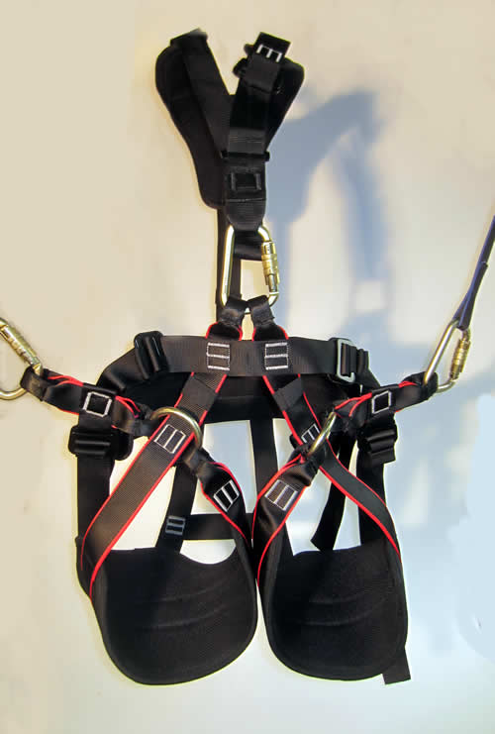 | Function: climb and zip.  Easy to walk in – the best option for course with lots of walking and long zip lines.  One harness for both rope parks and dual zip lines.  Works with all trolley types.  Available in two sizes (rider weight):  S-M (80-120 lbs)  L-XL (120 – 270 lbs)  Waist Size:22” to 44”, 27” to 51”  Has a redundant center hard point.  Weight – around 1.5 kg  Not Certified
FreeStyle GM  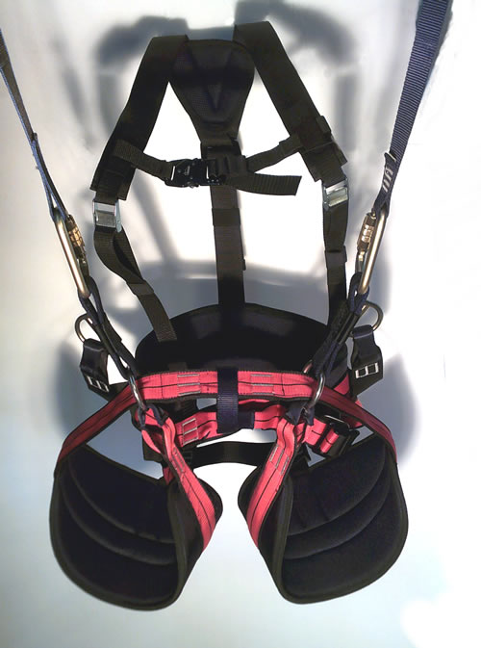 | Function: climb and zip.  Easy to walk in – the best option for course with lots of walking and long zip lines.  One harness for both rope parks and dual zip lines.  Works with all trolley types.  Available in three sizes (rider weight):  XS-M (80-120 lbs)  M-XL (100-230 lbs)  L-XXL (220 – 300 lbs)  Has one full strength center hard point.  Weight – around 1.5 kg  Certified EN 1651 and EN 12491

Balboa Harness  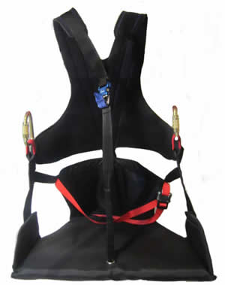 | Function: Full chair zip.  Limited stock  Delivery 3-4 week after payments  Most comfortable to ride  Maximum Safety  Easy to walk in  Has wooden seat board  Available in blue (unless we start a new build)  Spreader bar MTL is optional  Designed for riders that weigh between 200 and 300 lbs.  This is the largest zip line harness available anywhere!  Not Certified
Zip Guide (L and XL)  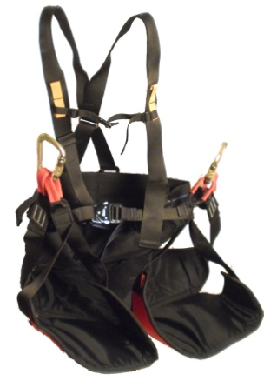 | Function: Full chair zip.  In stock  Comfortable ride – best choice for hot environments.  Inverted riders not allowed  Very easy to walk in  No wooden seat (has Cordura instead)  **Must use Spreader Bar MTL  ** Must use Trolley J225  Not Certified  Waist Size Range:  Size L (120-200lbs)  Size XL - (180 – 260 lbs)  Not Certified

Zip D-Lite XS  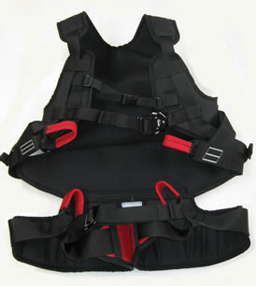 | Function: Full chair zip.  Not in stock  Delivery 4-6 weeks after payment  Comfortable ride  Maximum safety  Very easy to walk in  No wooden seat (has cordura instead)  **Must use Spreader Bar MTL  ** Must Use Trolley J225  Usual Color is black inside red outside  Available in just one size XS  Not Certified  Rider Age:  5 to 12  50 to 90lbs

Zip Standard II (S, L and XL)  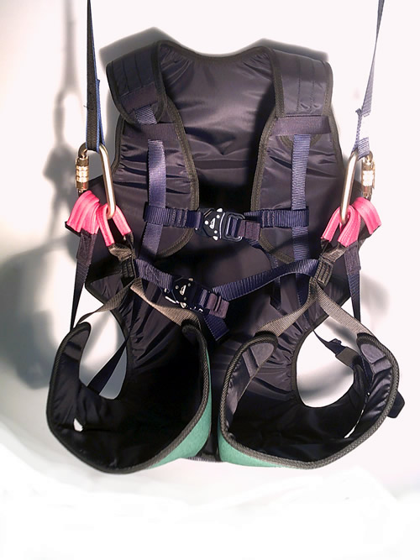 | Function: Full chair zip.  Comfortable ride  Maximum safety  Very easy to walk in  No wooden seat (has Cordura instead)  **Must use Spreader Bar MTL  ** Must use Trolley J225  Rider Weight:  XS (50 – 90 lbs) – special order (see D-Lite XS).  S (80-170 lbs)  L (160-210 lbs)  XL (up to 250 lbs)  Certified EN 1651

ECO Woody (XS-S)  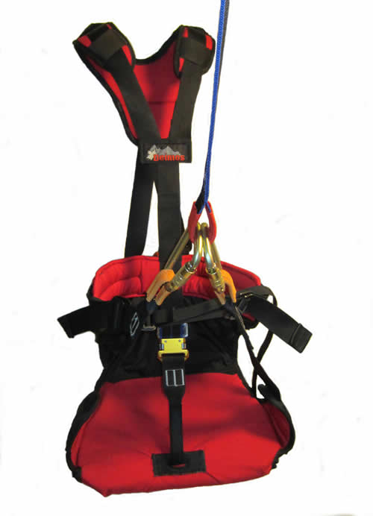 | Function: Full chair zip.  Limited Stock  Most comfortable to ride  Maximum Safety  Easy to walk in  Has wooden seat board  Available in red/navy  Spreader bar MTL is optional  Not Certified  Rider Age:  2-11  Not Certified

ECO Woody (S-L)  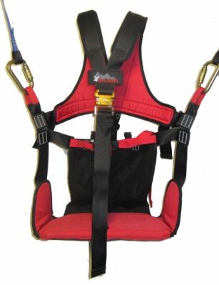 | Function: Full chair zip.  Limited stock  Delivery 3-4 week after payments  Most comfortable to ride  Maximum Safety  Easy to walk in  Has wooden seat board  Available in red (unless we start a new build)  Spreader bar MTL is optional  Rider Age:  8 and up  Not Certified

**Trolley J225  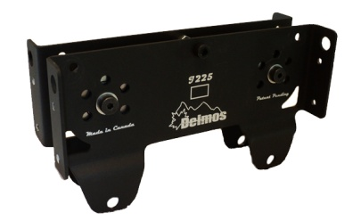 | Limited Stock  Available for cable sizes ½, 5/8”, ¾”, 7/8”, 1.25”  ** Must Use Spreader Bar MTL  Weight about 3 lbs  Not Certified

**Spreader Bar MTL  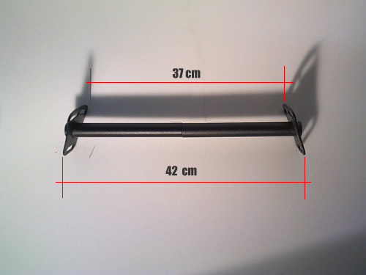 | Limited Stock  Includes free lanyards (four on top and two on the bottom).  Recommended for  FreeStyle RD and GM  ECO Woody XS  ECO Woody (S-L)  Zip D-Lite XS  Zip Standard II (S, L and XL)  Balboa  Not Certified

